**Proposal  
Document**

**BigBag - Desktop Application**

SEP



**Table of Contents**

Problem Statement 3

Problem Solution and Scope 3

Basic Features 3

Project Plan 4

Modular Breakdown 4

Team Members & Roles 4

Prototype 6

Itteration 1st 6

User Stories for User Management and Security  7

User Stories for Expense and Income Managment 8

Structured Specifications of user Stories 9

Sub User Stories  10

Scrum Board  12

Function Requirement Specifications  14

NFR specifications  15

Implementation 16

Itteration 2nd 20

User Stories for Budeting and Analytics 20

Strcutured Specifications of user Stories 21

Sub User Stories 22

Scrum Board 25

Function Requirement Specifications 27

NFR Specifications  28

Implmentation 29

Activity Diagram 34

Usecase Diagram 35

Sequential Diagram 36

Class Diagram 37

# 

# Problem Statement

In today's increasingly complex financial landscape, efficient and user-friendly financial management tools are paramount. Many individuals struggle to maintain a clear and organized view of their finances, leading to confusion, missed opportunities, and potential financial instability. Developing and adhering to budgets is often a daunting task, resulting in overspending, inadequate savings, and financial stress. Limited access to comprehensive investment insights and analysis leaves users uncertain about their investment decisions, potentially leading to missed opportunities and suboptimal returns. Navigating the complexities of tax regulations is a significant challenge for both individuals and businesses, often resulting in compliance issues, penalties, and lost deductions. Many users lack the financial knowledge required to make informed decisions, plan for their future, and secure their financial well-being.

# Problem Solution and Scope

BigBag will empower users to effortlessly track their expenses, record various sources of income, and effectively categorize their expenditures. With the ability to create customized spending categories and set monthly or yearly budgets, users will gain greater control over their financial health. The app will offer robust expense analytics, including detailed reports and visually appealing graphs, offering users invaluable insights into their spending patterns and financial habits. Furthermore, BigBag will support multiple currencies to cater to an international user base, ensuring that users from across the globe can benefit from its features. Security and data privacy will be paramount, with the implementation of secure user login and encryption mechanisms to safeguard user information.

# Basic Features

* **Expense Recording:**

Users can input expenses, including the amount, date, currency, and category.

* **Income Tracking**:

Record various sources of income with descriptions.

* **Expense Categories**:

Create and manage custom spending categories.

* **Budget Management:**

Set and monitor monthly or yearly budgets for different expense categories.

* **Expense Analytics:**

Generate detailed reports to visualize spending habits.

* **Currency Conversion**:

Support for multiple currencies to accommodate international users.

* **Data Security:**

Implement secure user authentication and data encryption for privacy.

# Project Plan

### Modular Breakdown

|  |  |  |
| --- | --- | --- |
| **Iteration** | **Module** | **Deliverables & Features** |
| 0 | Project Plan | -Problem Statement  -Problem Solution  -Discussing Basic Features  -What makes u Different  -Prototype |
| 1 | User Management & Security | - User registration/login - Data encryption  - Basic profile management |
| 2 | Expense & Income Management | - Expense recording (amount, date, currency, category)  - Income tracking  - Custom expense categories creation |
| 3 | Budgeting and Analytics | - Budget setting & monitoring for expense categories  - Expense analytics (reports & graphs)  - Currency conversion feature |

### Team Members & Roles

|  |  |
| --- | --- |
| **Name** | **Role** |
| Ali Hashim | Requirement Engineer & Lead Developer |
| Ayyan Ahmad | Project Lead, Designer & Architect |
| Hamza Jaffer | Developer & Tester |

# Prototype:

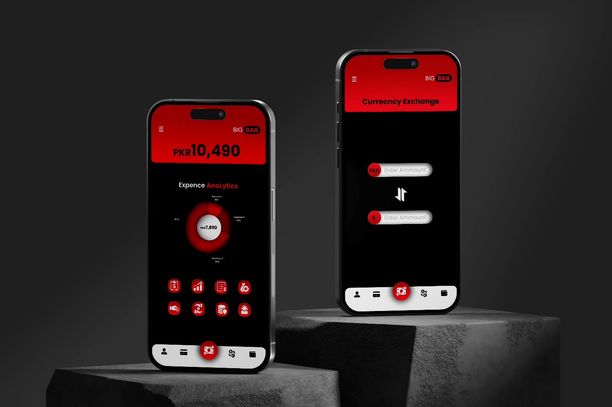

**USER STORIES FOR**

**User Management & Security Module:**

**Story ID:** 1

**Title:** User registration

As a new user, I want to register with my email and password, so I can access the application

securely.

**Acceptance Criteria:**

* User enters valid email and password.
* System verifies the email format and password strength.
* User receives a confirmation email for successful registration.

**Story ID:** 2

**Title:** User login Management

As a registered user, I want to log in using my credentials, so I can access my account and data securely.

**Acceptance Criteria:**

* User provides valid email and password.
* System verifies the credentials and grants access if they are correct.
* User sees their dashboard upon successful login.

**Story ID:** 3

**Title:** Data encryption

As a user, I want my data (such as passwords and sensitive information) to be encrypted, ensuring security and privacy.

**Acceptance Criteria:**

* System encrypts user passwords and sensitive data using industry-standard encryption algorithms.
* Encrypted data is securely stored and can only be decrypted with the correct keys.
* Users can access and modify their data securely.

**Story ID:** 4

**Title:** Basic profile management

As a user, I want basic profile management features to update my personal information.

**Acceptance Criteria:**

* User can edit and save their profile information, including name, email, and contact details.
* Changes made to the profile are reflected accurately throughout the application.
* Users can view their updated profile information after saving changes.

**USER STORIES FOR**

**Expense & Income Management Module:**

**Story ID:** 1

**Title:** Expense recording (amount, date, currency, category)

As a user, I want to record my expenses, including amount, date, currency, and category, for better financial tracking.

**Acceptance Criteria:**

* User can enter expense details such as amount, date, currency, and select a category.
* System stores the expense data securely and associates it with the user's account.
* Users can view a list of their recorded expenses and filter them by date or category.

**Story ID:** 2

**Title:** - Income tracking

As a user, I want to track my income sources to monitor my overall financial status.

**Acceptance Criteria:**

* User can add income details such as amount, date, and source.
* Income data is stored securely and displayed alongside expense data.
* Users can view a summary of their total income over a specific period.

**Story ID:** 3

**Title:** Custom expense categories creation

As a user, I want the ability to create custom expense categories to organize my expenses better.

**Acceptance Criteria:**

* User can create new expense categories and assign expenses to them.
* System allows for editing and deleting custom categories as needed.
* Custom categories are displayed in the expense management section for easy access.

**Structured Specifications of User Stories:**

User Management & Security Module:

* **User Registration/Login:**

**Input:** User enters a valid email address and password during registration.

**Process**: The system validates the email format and password strength.

If validation passes, the system generates a confirmation email and sends it to the user.

**Output**: User receives a confirmation email for successful registration.

* **Data Encryption:**

Input: User inputs sensitive data such as passwords or personal information.

Process: The system encrypts the data using industry-standard encryption algorithms.

Encrypted data is securely stored in the database.

Output: Encrypted data is stored securely and can only be decrypted with the correct keys.

* **Basic Profile Management:**

**Input:** User modifies their profile information (e.g., name, email, contact details).

**Process:** User updates the desired fields in the profile.

The system validates the changes and updates the database.

**Output**: Updated profile information is displayed to the user.

Expense & Income Management Module:

* **Expense Recording:**

**Input:** User enters expense details (amount, date, currency, category).

**Process:** The system validates the entered data for accuracy and completeness.

Validated data is stored securely in the database.

**Output**: User sees a confirmation of the recorded expense.

* **Income Tracking:**

**Input**: User adds income details (amount, date, source).

**Process:** The system verifies the entered data and stores it in the income records.

Income data is associated with the user's account for tracking purposes.

**Output:** User receives confirmation of the added income.

* **Custom Expense Categories Creation:**

**Input**: User creates new expense categories.

**Process:** User provides a name and description for the new category.

The system adds the category to the list of available expense categories.

**Output:** Newly created expense categories are visible for selection during expense recording.

**SUB- USER STORIES**

1. **User Management & Security: User Registration/Login**

**Sub-User Story 1:**

As a new user, I want to register an account with my email and password so that I can access the system securely.

**Acceptance Criteria:**

* I can navigate to the registration page from the home screen.
* I must provide a valid email address and a password containing at least 8 characters, including uppercase, lowercase letters, numbers, and special characters.
* Upon successful registration, I receive a confirmation email to verify my account.

**Sub-User Story 2:**

As a registered user, I want to log in to my account using my credentials to access personalized features.

**Acceptance Criteria:**

* I can access the login page from the home screen.
* I must enter my registered email and password to log in.
* After successful login, I am redirected to my dashboard with personalized options.

1. **Data Encryption**

**Sub-User Story 1:**

As a system administrator, I want to implement encryption algorithms to secure user data stored in the database.

**Acceptance Criteria:**

* Data such as passwords and sensitive user information must be encrypted using AES-256 encryption before storage.
* Only authorized users with decryption keys can access and view encrypted data.

1. **Basic Profile Management**

**Sub-User Story 1:**

As a logged-in user, I want to update my profile information such as name, email, and password.

**Acceptance Criteria:**

* I can navigate to the profile settings page from the dashboard.
* I can edit my name, email address, and password.
* Changes to the profile are saved and reflected in the system.

**Sub-User Story 2:**

As a user, I want to upload a profile picture to personalize my account.

**Acceptance Criteria:**

* I can upload an image file from my device on the profile settings page.
* The uploaded profile picture is displayed on my dashboard and account information.

1. **Expense & Income Management**

**Sub-User Story 1:**

As a user, I want to record my expenses by entering details such as amount, date, currency, and category.

**Acceptance Criteria:**

* I can access the expense recording feature from the dashboard.
* I enter the amount, date, currency (if applicable), and select a category for the expense.
* The recorded expense is saved and visible in my expense history.

**Sub-User Story 2:**

As a user, I want to track my income by entering details such as amount, date, and source.

**Acceptance Criteria:**

* I can access the income tracking feature from the dashboard.
* I enter the amount, date, and source of income.
* The recorded income is saved and visible in my income history.

**Sub-User Story 3:**

As a user, I want the ability to create custom expense categories to organize my expenses better.

**Acceptance Criteria:**

* I can navigate to the custom categories section from the expense management page.
* I create a new custom category with a unique name and description.
* The custom category is added to the list of available categories for expense recording

**Scrum Board**

**Functional Requirement Specifications**

|  |  |
| --- | --- |
| **Title** | **Description** |
| **User Registration/Login** | Users can create new accounts and log in securely. |
| **Data Encryption** | User data, especially sensitive information, is encrypted to ensure confidentiality |
| **Basic Profile Management** | Users can manage their basic profile information such as name, email, and password |
| **Expense Recording** | Users can record expenses including amount, date, currency, and category. |
| **Income Tracking** | Users can track their income sources. |
| **Custom Expense Categories Creation** | Users can create custom categories for expenses to better organize their financial data. |

**Non Functional Requirement Specifications**

**(NFR)**

|  |  |
| --- | --- |
| **Title** | **Description** |
| **Performance** | The system should respond quickly to user actions such as logging in, recording expenses, and accessing profile information. |
| **Security** | User data must be securely stored and transmitted to prevent unauthorized access or data breaches. |
| **Usuability** | The system should be user-friendly, with intuitive interfaces for tasks like registration, login, expense recording, and profile management |
| **Reliability** | The system should be reliable, with minimal downtime and robust error handling. |
| **Scalibility** | The system should be scalable to accommodate a growing user base and increasing data volume. |
| **Compatibility** | The system should be compatible with different devices, browsers, and operating systems. |
| **Maintainability** | The system should be easy to maintain and update over time. |

**Itteration 1 Implementaion**

**Email Validation**

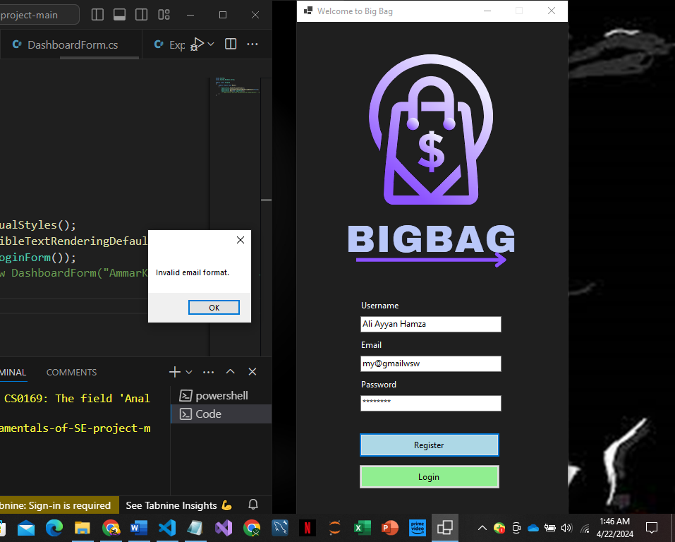

**Password validation**

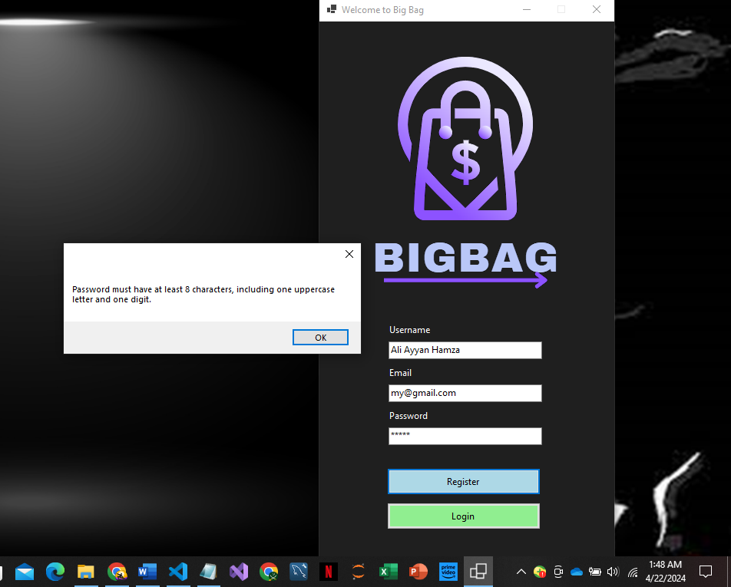

**Registration**

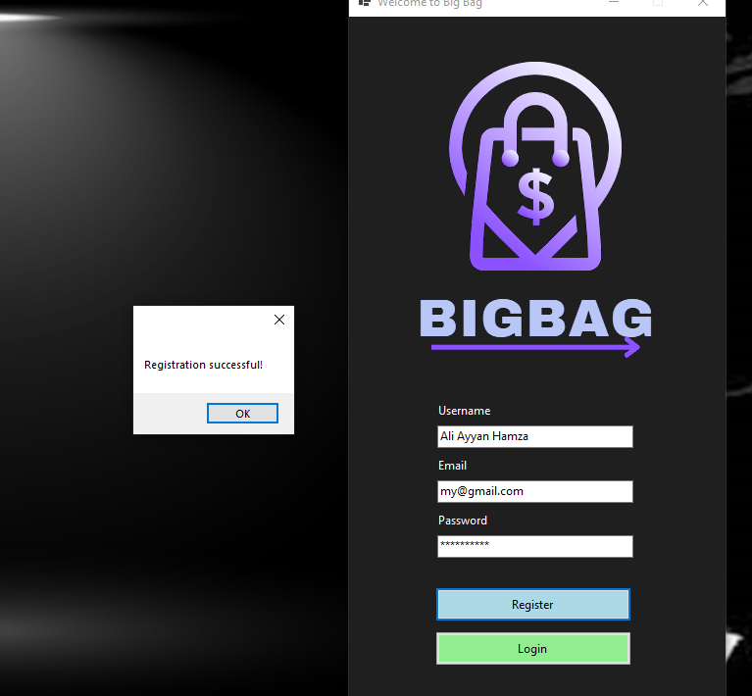

**Login**

**Dashboard**

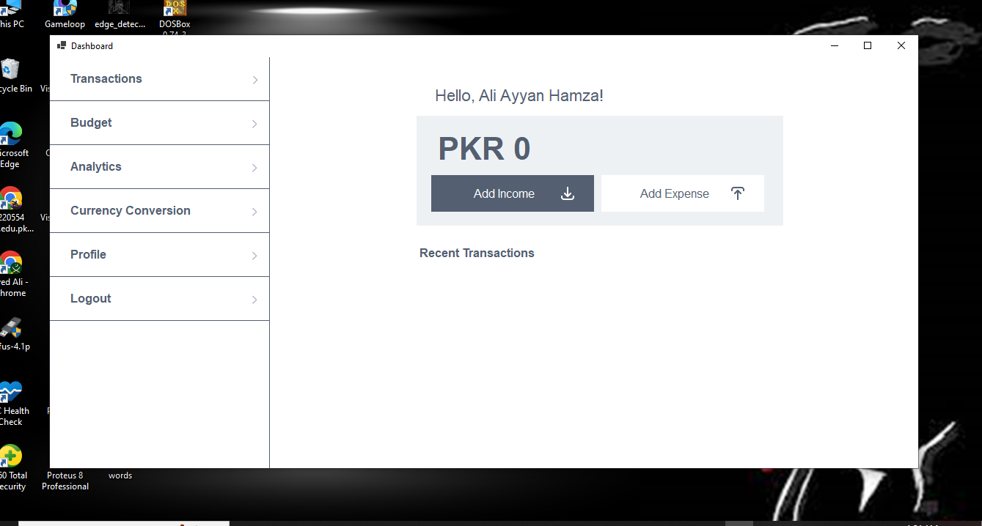

**Profile Management**

**Expense Record**

**Database:**

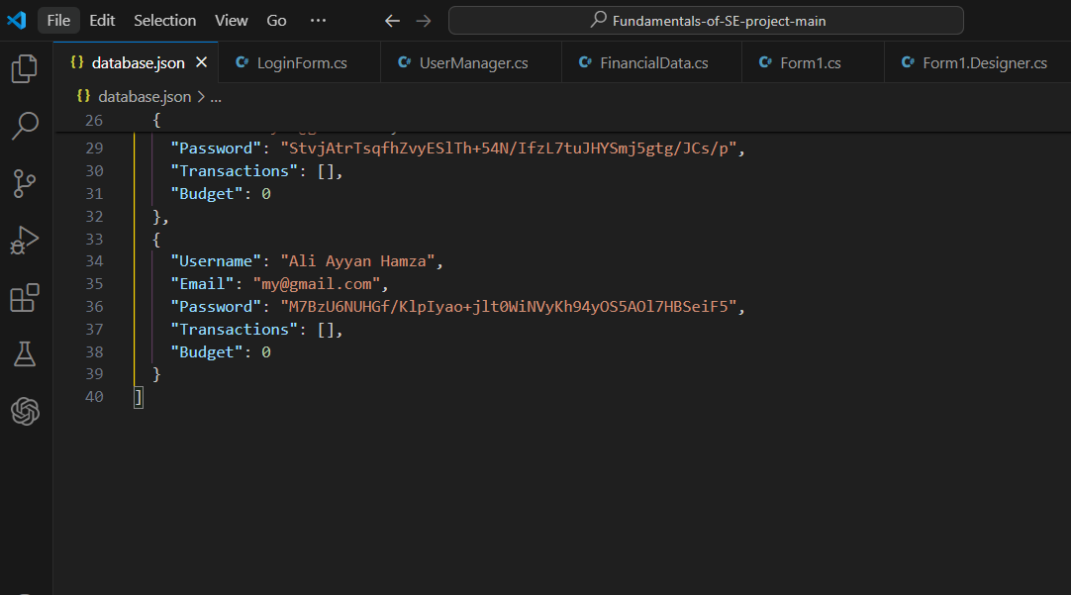

**USER STORIES FOR**

**Budgeting and Analytics Module:**

**Story ID:** 1

**Title:** Budget Setting & Monitoring

As a user, I want to set budget limits for different expense categories to manage my spending effectively.

**Acceptance Criteria:**

* Users can define budget amounts for specific expense categories.
* The system notifies users when they exceed their budget limits.
* Users can view a summary of their budget allocations and spending against each category.

**Story ID:** 2

**Title:** Expense Analytics (Reports & Graphs)

As a user, I want to generate detailed reports and graphs based on my expense data for better financial analysis.

**Acceptance Criteria:**

* Users can generate reports showing expenses over time, categorized by expense types.
* The system provides graphical representations such as pie charts or bar graphs for visualizing expense patterns.
* Users can filter reports by date range, expense categories, or specific transactions

**Story ID:** 3

**Title:** Currency Conversion Feature

As a user, I want to convert expenses or budgets from one currency to another for international financial management

**Acceptance Criteria:**

* Users can select the currency they want to convert from and to.
* The system fetches real-time exchange rates to perform accurate currency conversions.
* Converted amounts are displayed alongside original amounts for easy comparison.

**Story ID:** 4

**Title:** Database Management

As a system, I need to securely store user data, including transactions, budgets, usernames, emails, and passwords in a file

**Acceptance Criteria:**

* User registration data is stored securely.
* Transaction details are recorded accurately and securely.
* The system ensures data integrity and protection against unauthorized access.

**Story ID:** 5

**Title:** Dashboard Navigation

As a user, I want to navigate seamlessly between budget setting, analytics, and currency conversion features from the main dashboard.

**Acceptance Criteria:**

* The dashboard provides intuitive navigation links for budget setting, analytics, and currency conversion.
* Users can access these features with minimal clicks, enhancing user experience and efficiency.

**Structured Specifications of User Stories:**

* **Budget Setting & Monitoring**

**Input:** User-defined budget limits for expense categories.

**Process:** Users input budget amounts for specific expense categories through the application interface. The system validates and securely stores the budget limits in the database.

**Output:** Budget limits, notifications for exceeding limits, real-time dashboard updates.

* **Expense Analytics (Reports & Graphs)**

**Input:** Selected date ranges and expense categories for report generation.

**Process:** The system generates detailed reports showing expenses over time, categorized by types such as groceries, utilities, entertainment, etc. Graphical representations like pie charts or bar graphs visualize expense patterns.

**Output:** Custom reports, graphical representations, filtering options.

* **Currency Conversion Feature**

**Input:** Original and target currencies for conversion.

**Process:** Users select the original currency and target currency for conversion. The system fetches real-time exchange rates from a reliable source. Converted amounts are displayed alongside original amounts for comparison.

**Output:** Converted amounts, real-time exchange rates.

* **Database Management**

**Input:** User registration data, transaction details.

**Process:** Encrypt and securely store user registration data in the json file. Record transaction details accurately, including amount, date, currency, and category. Ensure data integrity and protection against unauthorized access through encryption and access control measures.

**Output:** Encrypted user data, secure transaction records.

* **Dashboard Navigation**

**Input:** Dashboard navigation links for budget setting, analytics, and currency conversion.

**Process:** Provide clear and labeled navigation links on the main dashboard. Ensure intuitive access to budget setting, analytics, and currency conversion functionalities. Maintain consistency and user-friendliness across different screens and modules.

**Output:** Intuitive navigation, easy access to features.

**SUB- USER STORIES**

1. **Budget Setting & Monitoring**

**Sub-User Story 1:**

As a budget-conscious user, I want to set limits on my spending categories so that I can manage my expenses effectively.

**Acceptance Criteria:**

* Users can input budget limits for different expense categories.
* The system validates and saves these limits securely.
* Notifications are triggered when users approach or exceed their budget limits.

**Sub-User Story 2:**

As a financially aware user, I want to monitor my spending against set budgets to track my financial health.

**Acceptance Criteria:**

* Users can view real-time summaries of their budget allocations and actual spending.
* The dashboard updates dynamically to reflect current spending per category.
* Budget progress is visually represented to indicate remaining balances.

1. **Expense Analytics (Reports & Graphs)**

**Sub-User Story 1:**

As an analytical user, I want to generate custom reports to analyze my spending patterns and make informed financial decisions.

**Acceptance Criteria:**

* Users can select specific date ranges and expense categories for report generation.
* The system generates detailed reports with graphical representations like pie charts or bar graphs.
* Reports include key insights such as total spending, category-wise breakdown, and trends over time.

**Sub-User Story 2:**

As a data-savvy user, I want to filter and refine reports to focus on specific aspects of my financial data.

**Acceptance Criteria:**

* The system updates reports dynamically based on applied filters.
* Filtered reports provide detailed insights tailored to user preferences.

1. **Currency Conversion Feature**

**Sub-User Story 1:**

As an international user, I want to convert expenses into different currencies for accurate financial tracking.

**Acceptance Criteria:**

* Users can choose original and target currencies for conversion within the application.
* The system fetches real-time exchange rates from reliable sources for selected currencies.
* Converted amounts are displayed alongside original amounts for easy comparison.

.

1. **Database Management**

**Sub-User Story 1:**

As a privacy-conscious user, I want my registration data and transactions to be securely stored and protected from unauthorized access.

**Acceptance Criteria:**

* User registration data, including username, email, and password, is encrypted and securely stored in the database.
* Access control mechanisms ensure data protection and prevent unauthorized access to sensitive information.
* Encrypted data remains intact and retrievable for authorized users only.

**Sub-User Story 2:**

As a transaction-oriented user, I want accurate recording of transaction details to maintain a transparent financial record.

**Acceptance Criteria:**

* + Transaction details, such as amount, date, category, and currency, are recorded accurately in the database.
  + Data integrity measures ensure that recorded transactions are complete and consistent.
  + Encrypted transaction records are accessible for reporting, analysis, and historical tracking purposes.

**Scrum Board**

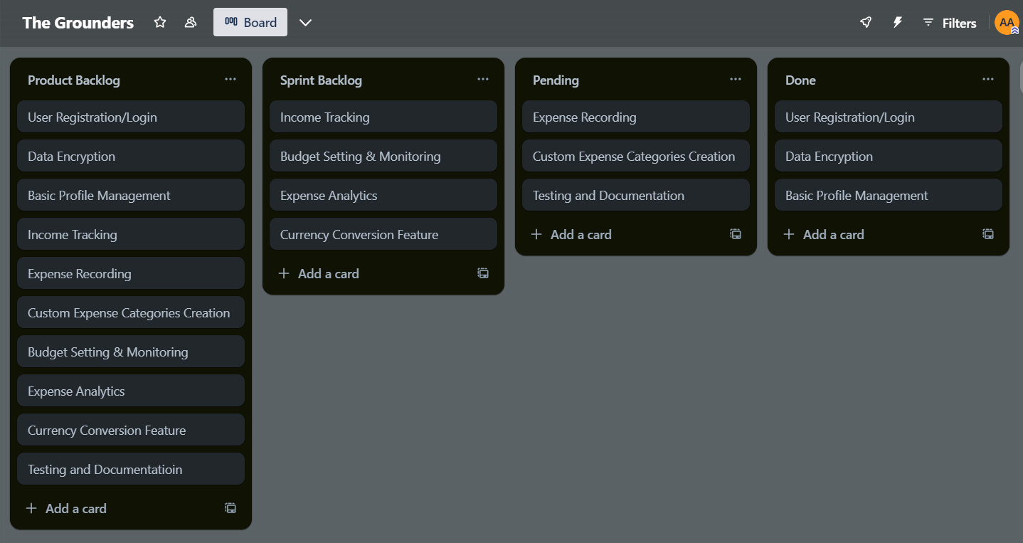

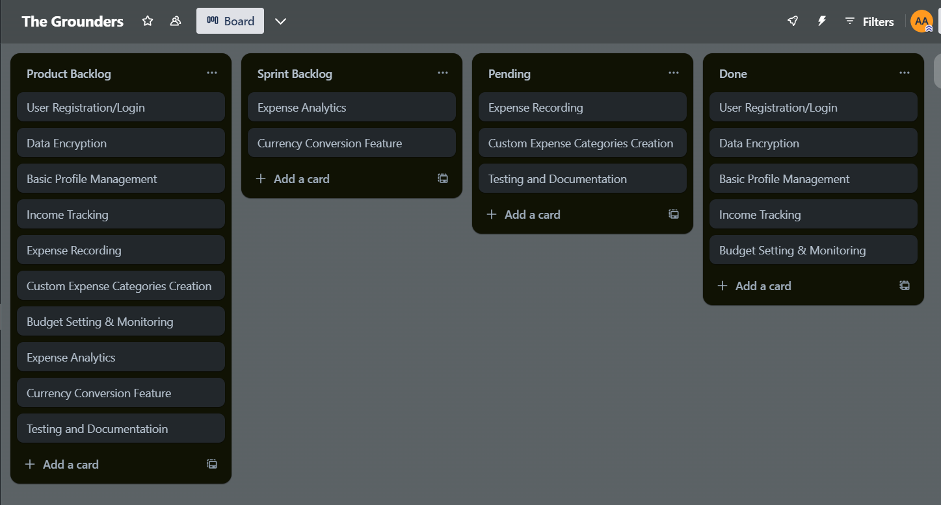

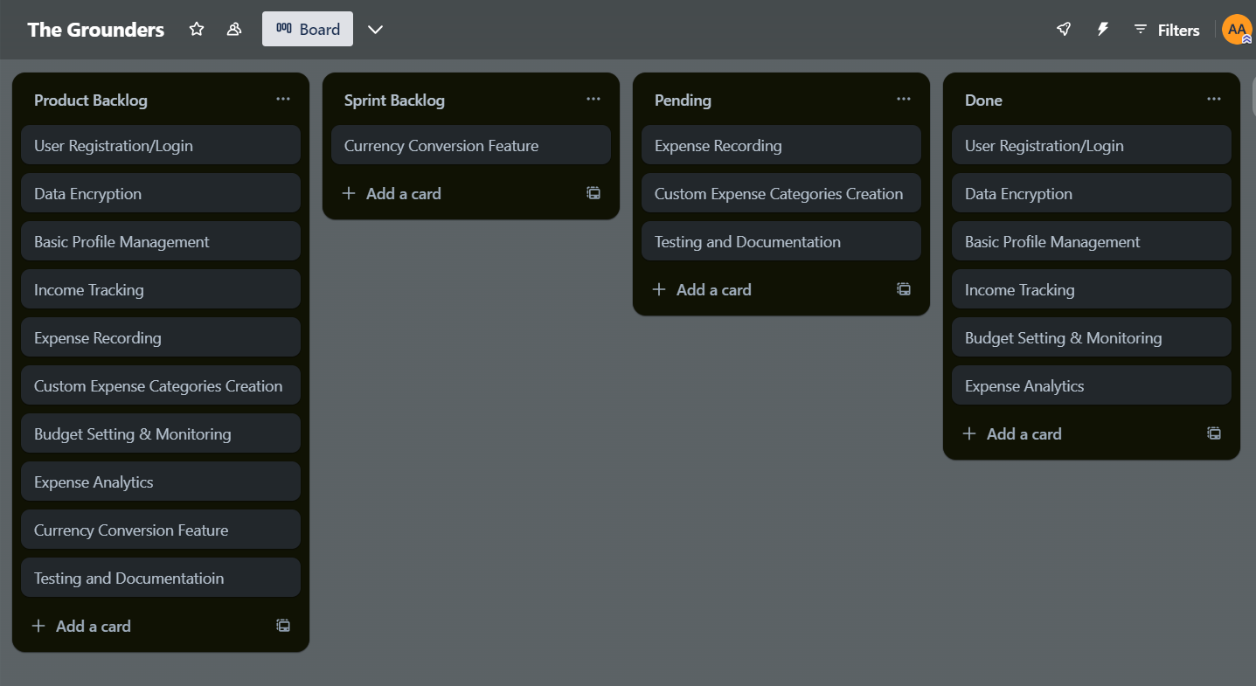

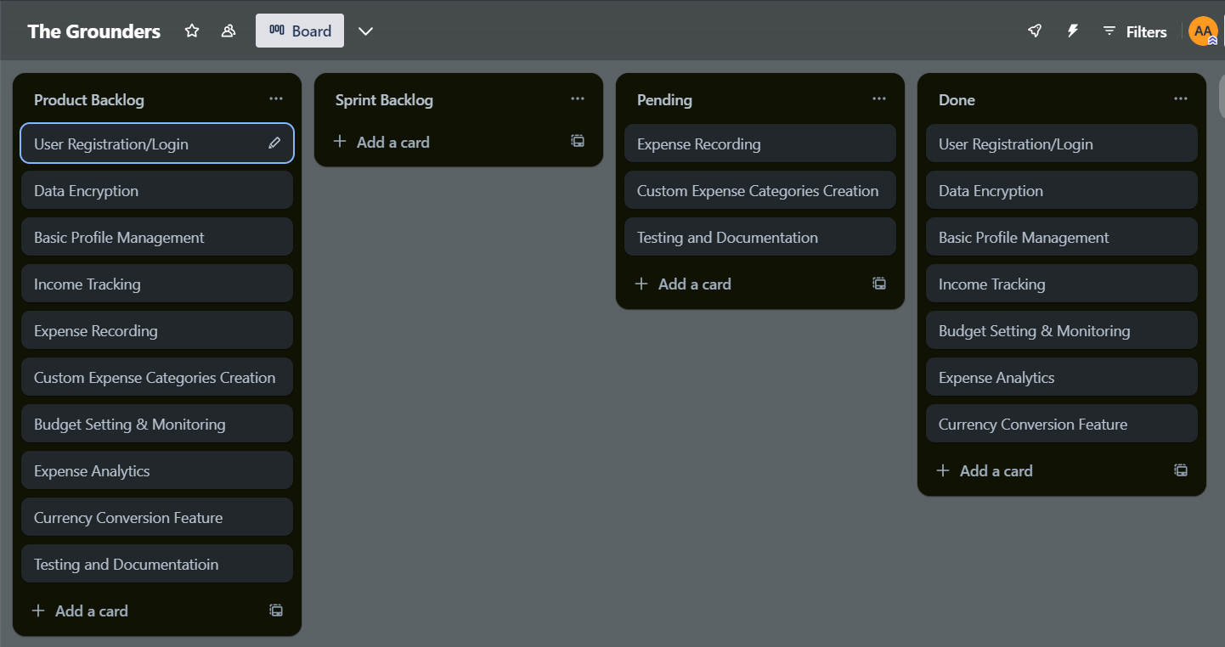

**Functional Requirement Specifications**

|  |  |
| --- | --- |
| **Title** | **Description** |
| **Set Budget Limits** | Allow users to set limits on their spending categories to manage expenses effectively. |
| **Monitor Budget Expenditure** | Provide users with real-time monitoring of their spending against set budgets to track financial health. |
| **Generate Custom Reports** | Enable users to generate custom reports for analyzing spending patterns and making informed financial decisions. |
| **Select Conversion Currencies** | Provide users with the ability to convert expenses into different currencies for accurate financial tracking. |
| **Record Transaction Details** | Record transaction details accurately to maintain a transparent financial record for users. |
| **Secure User Data Storage** | Ensure secure storage of user registration data and transactions to protect against unauthorized access. |

**Non Functional Requirement Specifications**

**(NFR)**

|  |  |
| --- | --- |
| **Title** | **Description** |
| **Performance** | The system should respond quickly to user actions such as logging in, recording expenses, and accessing profile information. |
| **Security** | User data must be securely stored and transmitted to prevent unauthorized access or data breaches. |
| **Usuability** | The system should be user-friendly, with intuitive interfaces for tasks like registration, login, expense recording, and profile management |
| **Reliability** | The system should be reliable, with minimal downtime and robust error handling. |
| **Scalibility** | The system should be scalable to accommodate a growing user base and increasing data volume. |
| **Compatibility** | The system should be compatible with different devices, browsers, and operating systems. |
| **Data Integrity** | Maintain data integrity in recording transaction details and generating accurate reports for users' financial analysis. |

**Itteration 2 Implementaion**

**Income Record**

**Budget Record**

**After expense of 8000 the total amount updates to 2500**

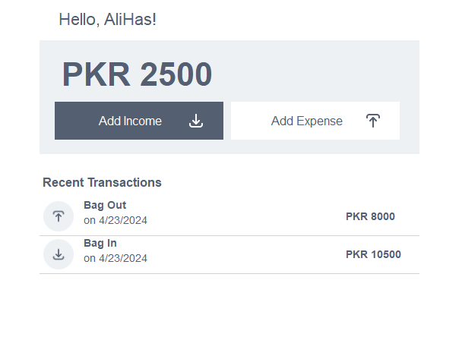

**If budget exceed**

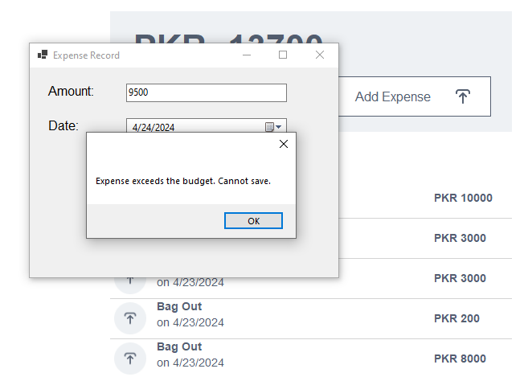

**Analytics Report**

**Transaction History**

**Amount Updation**

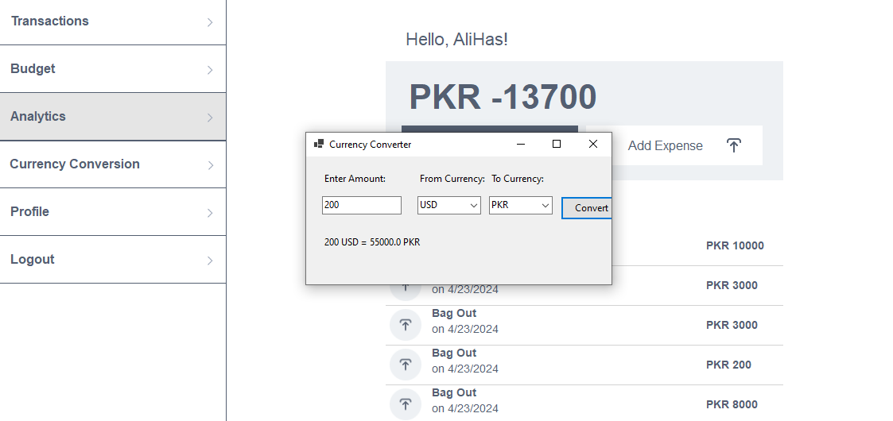

**Diagrams**

JPG format pictures also included in folder

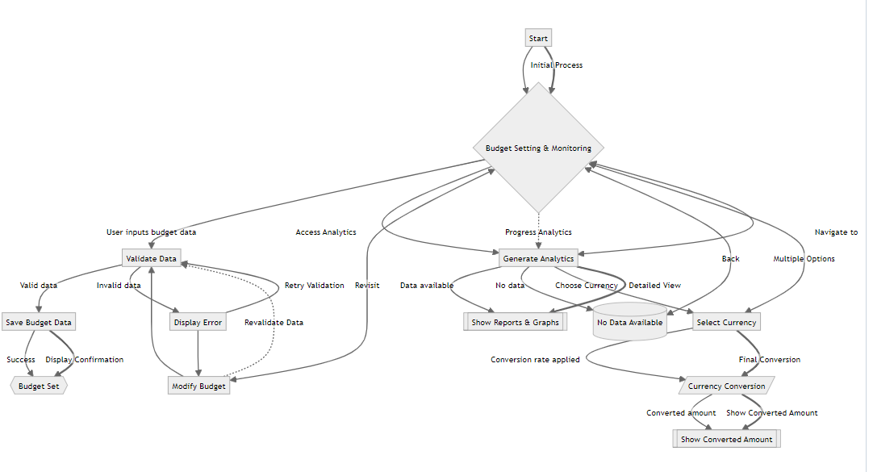**Activity Diagram**

**Sequence Diagram**

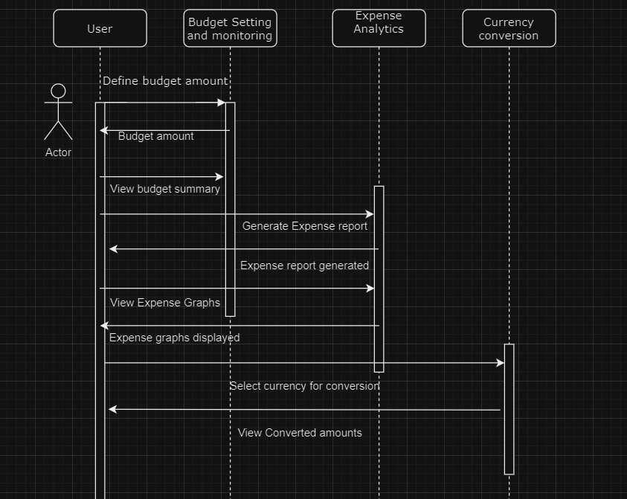

**UseCase Diagram**

**Class Diagram:**

Zoom in you get clear view

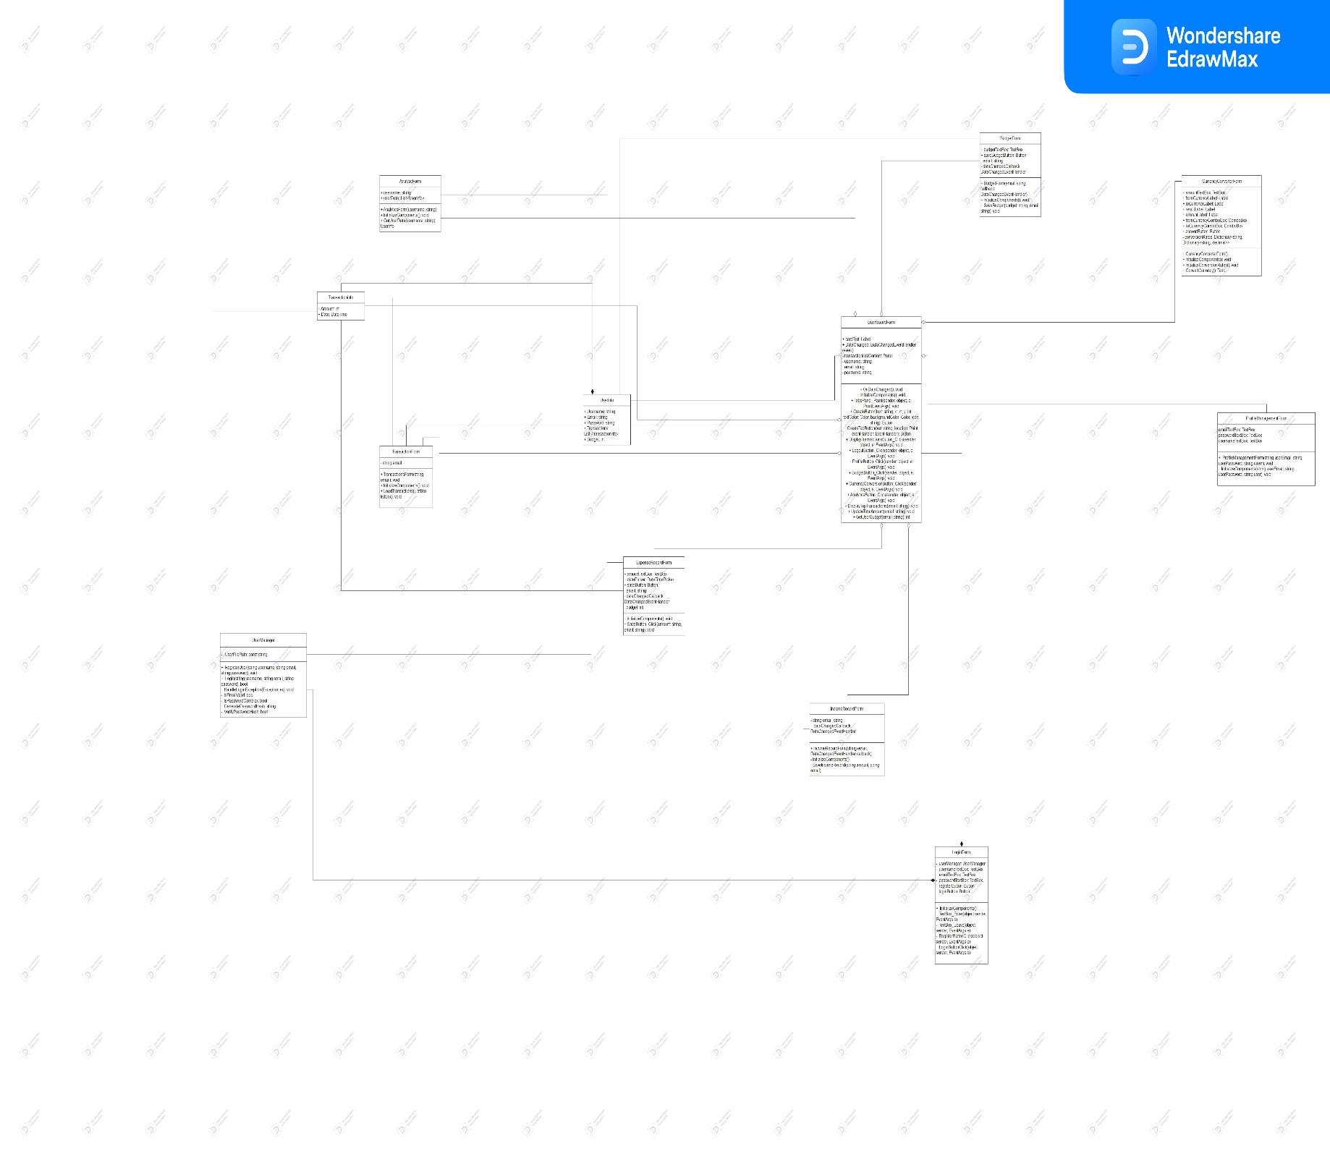

**Iteration 3**

In this iteration I have improved the following things:

* Added a new feature of BigBag Games
* Also improved the Visuals and interface
* Improved the Input validations and Improved security credentials.

Module : BigBag Games and Security Features

**USER STORIES FOR**

**BigBag Games and Security Features**

**Story ID:** 1

**Title:** Accessing BigBag Games

As a user, I want to access a variety of mini-games within the desktop app to enjoy and relax.

**Acceptance Criteria:**

* Users can navigate to the "BigBag Games" section from the main dashboard.
* The games are interactive and provide a fun experience for users.
* Users can return to the main dashboard seamlessly after playing games.

**Story ID:** 2

**Title:** Enhanced Input Validation

As a user, I want input fields to validate my data entries, ensuring correct formats and strong passwords.

**Acceptance Criteria:**

* Email input fields validate email format before submission.
* Passwords must include at least one uppercase letter, one lowercase letter, one number, and be at least 8 characters long.
* Users receive clear error messages for incorrect input formats or weak passwords.

**Story ID:** 3

**Title:** Secure Password Storage

As a user, I want input fields to validate my data entries, ensuring correct formats and strong passwords.

**Acceptance Criteria:**

* Passwords are encrypted using a strong hashing algorithm before storage in the database.
* Decryption is not possible, ensuring user data security even in case of a database breach.

**Story ID:** 4

**Title:** Enhanced Dashboard Visuals

As a user, I want the dashboard to have improved visual elements for better usability and aesthetics.

**Acceptance Criteria:**

* The dashboard layout is intuitive, with clear navigation elements and organized sections.
* Visual elements such as icons, color schemes, and fonts are updated for a modern and appealing look.
* Users find it easier to navigate, understand, and interact with different features on the dashboard.

**Structured Specifications of User Stories:**

**Title:** Enhanced Input Validation

**Function:**

Ensuring correct email formats and strong password criteria during user registration and login. Description: This requirement aims to improve the security and usability of the system by validating user inputs, specifically email formats and password strength, before processing them further.

**In Input:** User-provided email and password during registration or login.

**Source:** Input fields in the registration and login forms.

**Output:** Validation status (valid/invalid) for email and password.

**Destination:** Registration/Login controller for processing user data.

**Action to be taken:**

* For email validation: Verify if the input matches the standard email format (e.g., username@domain.com).
* For password validation: Check if the password meets the criteria of having at least one uppercase letter, one lowercase letter, one number, and being at least 8 characters long.
* If the input meets the criteria, proceed with the registration or login process; otherwise, display an error message to the user.

**SUB- USER STORIES**

**User Story:**

**Title:** Enhanced Security Measures

**Sub-User Story 1:**

As a user, I want the system to validate email formats during registration and login to prevent errors and ensure data accuracy.

**Acceptance Criteria:**

The system verifies that the email entered during registration and login matches the standard email format (e.g., example@email.com).

Users are notified of any incorrect email formats and prompted to enter a valid email address.

**Sub-User Story 2:**

As a security-conscious user, I want the system to enforce password strength requirements to protect my account from unauthorized access.

Acceptance Criteria:

Passwords must contain at least one uppercase letter, one lowercase letter, and one number.

The system prompts users to create a password meeting these criteria during registration and password updates.

Users receive feedback on password strength to ensure they create secure passwords.

**Structured Specifications of Enhanced**

**Input Validation**

**Title:** Enhanced Input Validation

**Function:**

Ensuring correct email formats and strong password criteria during user registration and login. Description: This requirement aims to improve the security and usability of the system by validating user inputs, specifically email formats and password strength, before processing them further.

**In Input:** User-provided email and password during registration or login.

**Source:** Input fields in the registration and login forms.

**Output:** Validation status (valid/invalid) for email and password.

**Destination:** Registration/Login controller for processing user data.

**Action to be taken:**

* For email validation: Verify if the input matches the standard email format (e.g., username@domain.com).
* For password validation: Check if the password meets the criteria of having at least one uppercase letter, one lowercase letter, one number, and being at least 8 characters long.
* If the input meets the criteria, proceed with the registration or login process; otherwise, display an error message to the user.

**Scrum Board**

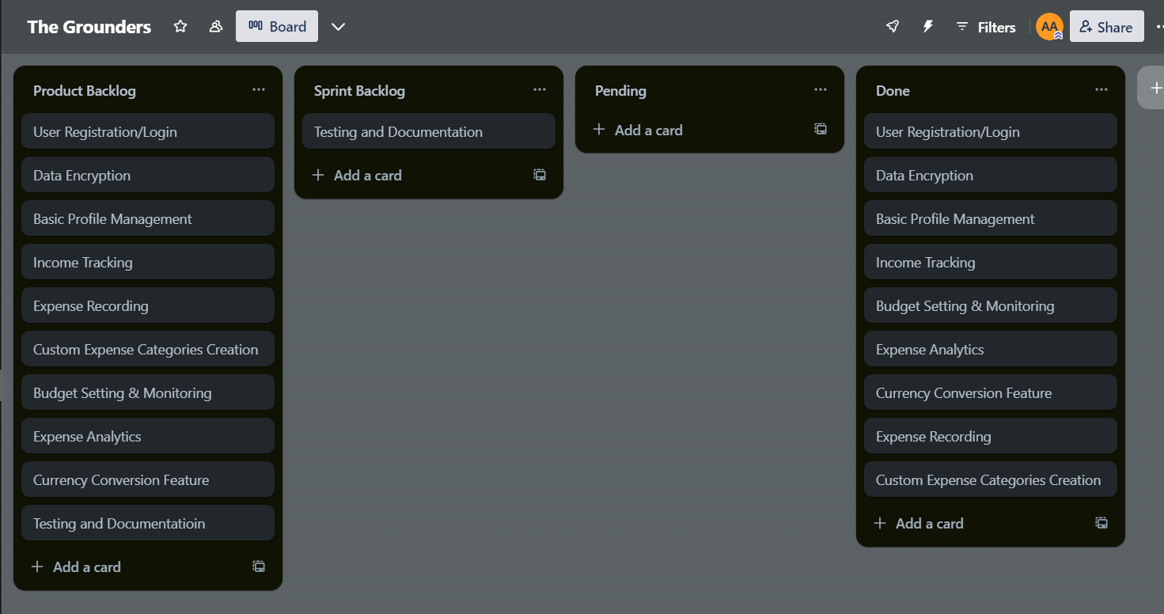

**Functional Requirement Specifications**

|  |  |
| --- | --- |
| **Title** | **Description** |
| **Big Bag Games Integration** | Implement integration with BigBag Games to provide users with a gaming experience within the desktop app. |
| **Enhanced Security Features** | Enhance security by implementing input validations for email formats and password strength criteria (minimum 8 characters, 1 uppercase letter, 1 lowercase letter, 1 number). |
| **Improved Dashboard Visuals** | Enhance the visual design of the dashboard to improve user experience and ease of navigation. |
| **Encrypted Password Storage** | Implement encryption for storing user passwords securely in the database.json file to protect sensitive user information. |

**Non Functional Requirement Specifications NFR**

|  |  |
| --- | --- |
| **Title** | **Description** |
| **Performance Optimization** | Ensure the app's responsiveness and performance are optimized to provide a smooth user experience, especially during gameplay and data processin |
| **Usability Enhancement** | Enhance the app's usability by improving the layout, navigation, and overall user interface design to make it intuitive and user-friendly. |
| **Security Compliance** | Ensure compliance with security standards and best practices for handling user data, including encryption, secure storage, and data validation. |
| **Visual Appeal** | Enhance the visual appeal of the app by using modern design elements, colors, and graphics to create an engaging user interface.. |

**Architecture Diagram**

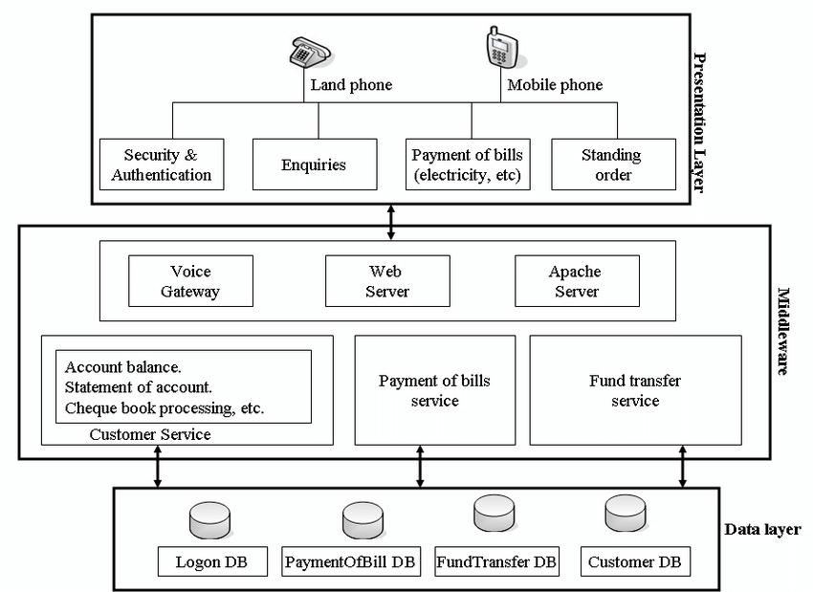

**Project Burn Down Chart**

**Boundary Value Testing**

**Over All Implementation**

**Work Division**

*In our project team, Ali took the lead in crafting detailed specifications and requirements, ensuring that every aspect of the financial management tool, from expense recording to budget analytics, was meticulously defined. He also contributed an innovative gaming feature to enhance user engagement. Hamza delved into the design realm, focusing on creating comprehensive diagrams that visually represented the project's architecture and functionality. His expertise in design ensured that the user interface was intuitive and aesthetically pleasing. Ayyan, with a keen eye on technical intricacies, worked on structuring the project's codebase, determining the optimal class structure, and guiding the implementation process. Together, their efforts resulted in a cohesive and robust financial management application that combines functionality, usability, and visual appeal.*

*Top of Form*

**Lesson**

1. **Holistic Project Management:** This project teaches students the importance of managing a project from inception to completion. From defining user requirements to designing user interfaces, implementing functionalities, and ensuring security measures, students gain hands-on experience in overseeing every aspect of a software project.
2. **Collaborative Teamwork:** Working in a team setting like this project fosters collaboration skills. Students learn how to communicate effectively, delegate tasks, and leverage each team member's strengths to achieve project goals efficiently. This collaborative environment mirrors real-world scenarios where teamwork is essential for success.
3. **Technical Proficiency:** Through developing features like expense recording, budget management, and analytics, students enhance their technical skills in programming, database management, and user interface design. They learn to write clean and efficient code, implement data storage solutions, and create intuitive user experiences.
4. **Problem-Solving and Innovation:** The challenges faced during project development encourage students to think critically and find innovative solutions. Whether it's implementing input validations, ensuring data security, or integrating new features like currency conversion and gaming elements, students hone their problem-solving abilities and push the boundaries of creativity.
5. **User-Centric Design:** Emphasizing user stories and acceptance criteria instills a user-centric design approach. Students learn the significance of understanding user needs, designing intuitive interfaces, and delivering functionalities that add tangible value to the end-user experience. This focus on usability and user satisfaction sets a strong foundation for future software development endeavors.

Overall, this project provides a rich learning experience that combines technical expertise, teamwork, problem-solving, and user-centric design principles, preparing students for diverse roles in the software development industry.

"***Individually, we are drops. Together, we are an ocean."***